How to Create a Voki Project
Instructions for the Student
What is a Voki? A Voki is an Avatar (a computerized character).
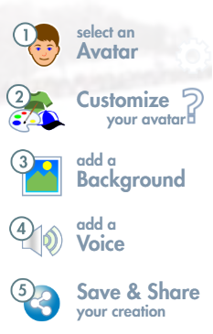
1.Go to: Voki.com

- Click on 'CREATE' (located on the top left- menu bar)

- Choose your character by clicking
- To change characters, click to see all choices.
  - Note: Characters with yellow star require a premium login.

- Choose your background by clicking

- Select your background to match your project topic.
- To add a Voice to the project Click
If a text box appears, click Allow.

- To type your project into the text box Click

Note: Use a period at the end of a sentence.
Optional: Select your character’s accent.
- To Speak your text, click to record your voice.
Speak slowly and clearly. Edit the text box to correct misspellings and add periods.

- Review and Save your Voki Project
- Click on the 'Play' icon to hear your text.(You can go back to editing at any time)
- When you are finished, click the Save icon in lower left.
- Enter your Voki project title and click save.
- Click 'No Thanks' in the text box that appears. You created a Voki Character.
- Click 'Close' in the text box that appears. (Your Scene has been saved.)

- Share Voki Character Link to Teacher
  - Click the link icon to get the URL to email your teacher.
  - Click COPY URL popup box
  - GO to FCS LAUNCHPAD, sign in to CLASSLINK,
  - Go to SEESAW Login, Click on your Name, select your class, Click the LINK ICON, At the “Share A LINK” page, Ctrl – V to place URL to your Voki Project into text box.

